In Java Spring Boot, @Transactional is an annotation used to manage database transactions. It tells Spring to handle the complexities of starting, committing, or rolling back a transaction automatically, so you don't have to write boilerplate JDBC or JPA transaction code.

Key Benefits & How It Works
- Automatic Management: When you place @Transactional on a method or class, Spring intercepts the method call, opens a database transaction before the code executes, and either commits the changes if everything succeeds or rolls back everything if an unchecked exception occurs.
- ACID Compliance: It ensures that your database operations adhere to ACID properties (Atomicity, Consistency, Isolation, Durability), which is critical when performing multiple related database writes (e.g., transferring money from one bank account to another).
- Declarative Approach: Instead of manually writing beginTransaction(), commit(), and rollback() logic, you simply declare your intent using the annotation.
- 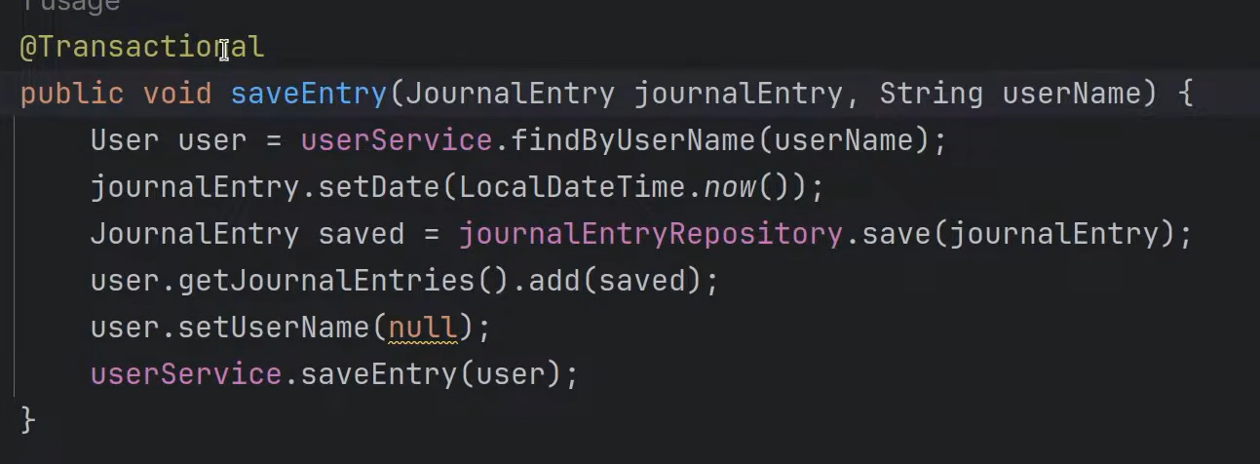

- 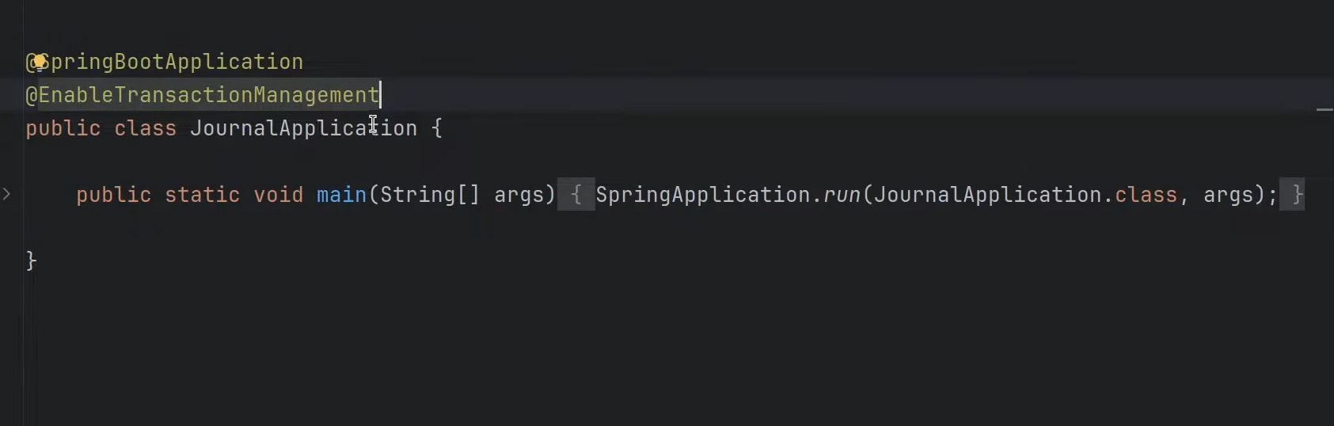

Common Use Cases & Code Example
You typically use @Transactional in your Service layer where business logic coordinates multiple database operations.
Java
import org.springframework.stereotype.Service;
import org.springframework.transaction.annotation.Transactional;

@Service
public class UserService {

private final UserRepository userRepository;
private final ProfileRepository profileRepository;

public UserService(UserRepository userRepository, ProfileRepository profileRepository) {
this.userRepository = userRepository;
this.profileRepository = profileRepository;
}

@Transactional
public void registerUser(User user, Profile profile) {
// If saving the profile fails, the user insert will also be rolled back
userRepository.save(user);
profileRepository.save(profile);
}
}

Important Attributes & Configurations
You can fine-tune how transactions behave using several optional parameters:
- propagation: Defines how transactions relate to each other if a transactional method calls another transactional method (e.g., Propagation.REQUIRED creates a new transaction if none exists, or joins an existing one).
- isolation: Controls the visibility of changes made by concurrent transactions (e.g., Isolation.READ_COMMITTED, Isolation.SERIALIZABLE).
- readOnly = true: Optimizes performance for read-only operations (like SELECT queries) by telling the underlying persistence provider that no writes will occur.
- rollbackFor: Specifies which exceptions trigger a rollback. By default, Spring only rolls back on unchecked exceptions (subclasses of RuntimeException and Error). If you want it to roll back on checked exceptions (like IOException), you must configure it explicitly:
Java
@Transactional(rollbackFor = Exception.class)

Common Pitfall: Self-Invocation
Spring implements @Transactional using proxies. When another bean calls a method annotated with @Transactional, the Spring proxy intercepts the call to manage the transaction.
If a method inside the same class calls another method within that same class that has @Transactional, the proxy is bypassed, and the transaction will not work.
Tip: Always place @Transactional on public methods of a separate service bean so that Spring's proxy can properly intercept them.
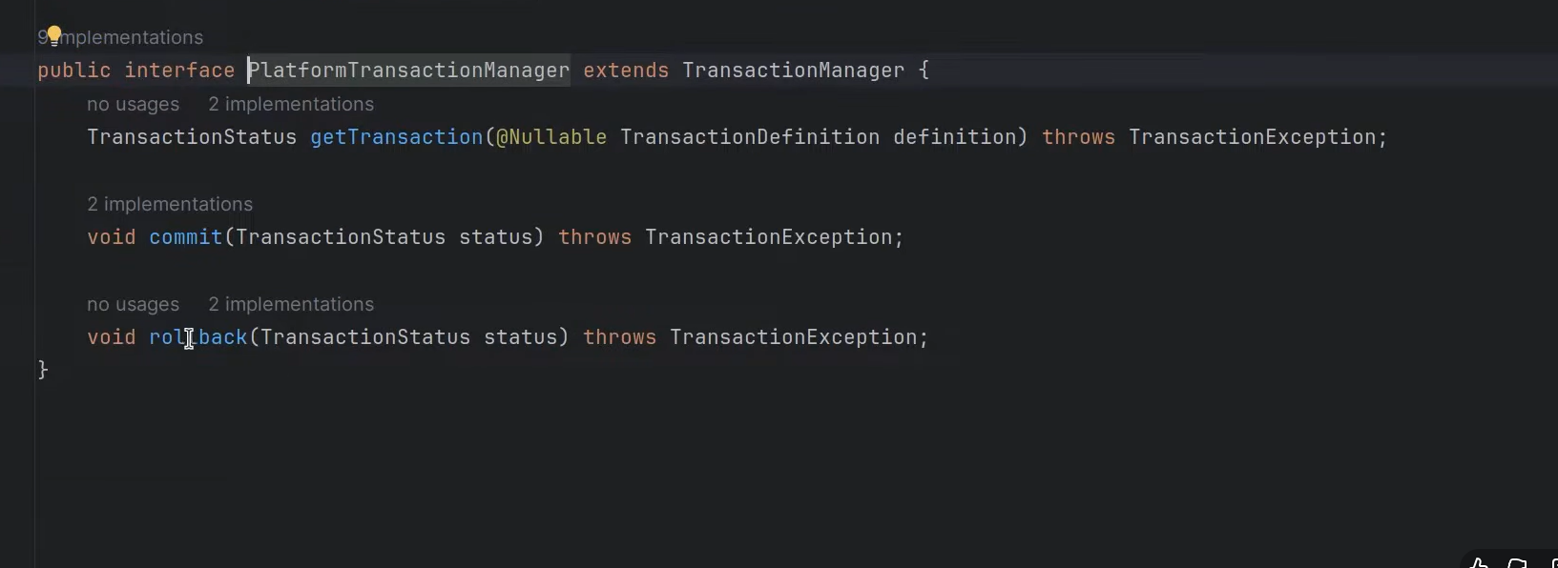
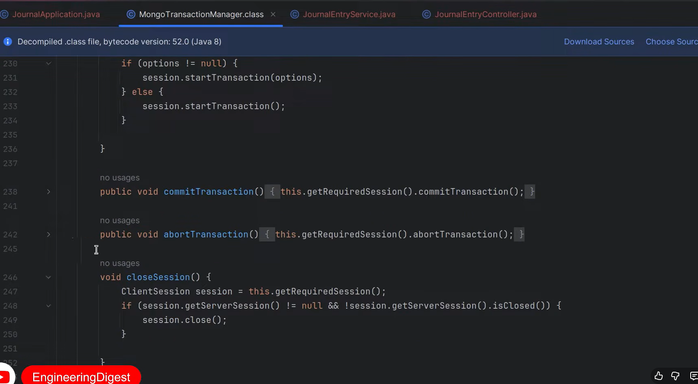
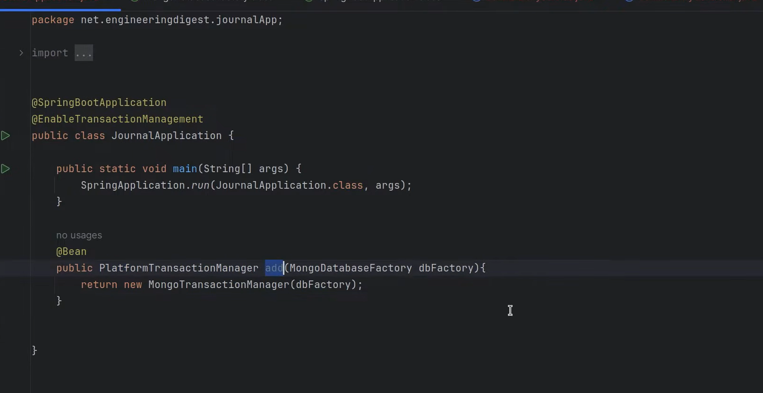
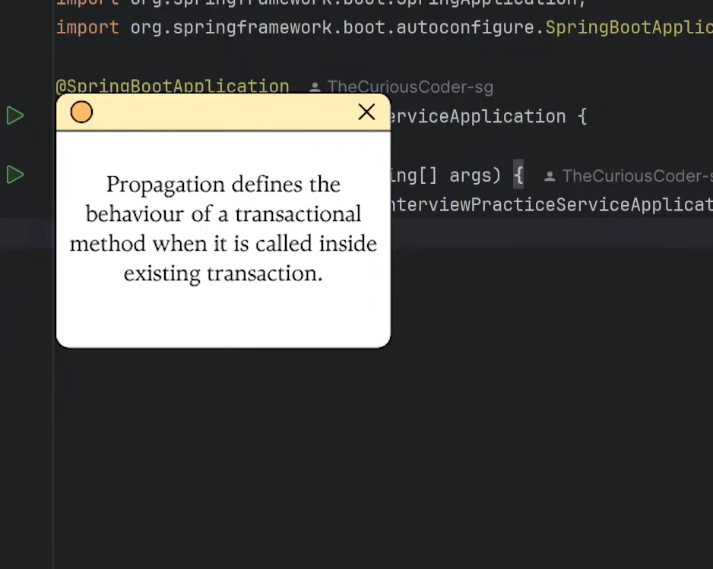
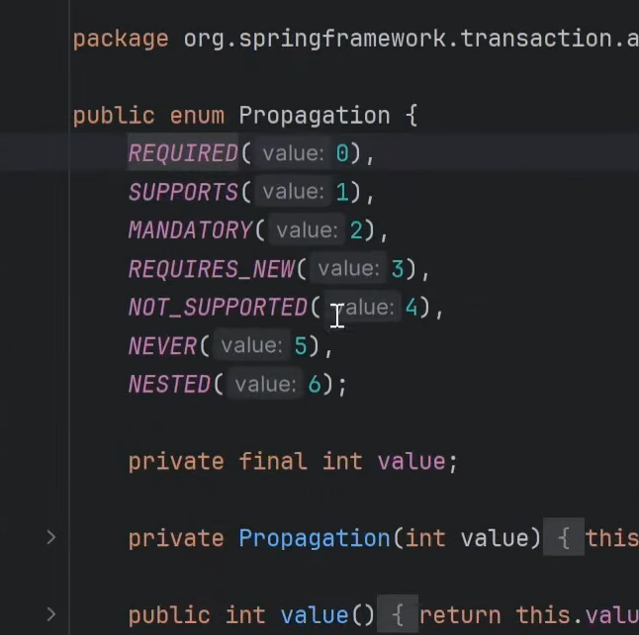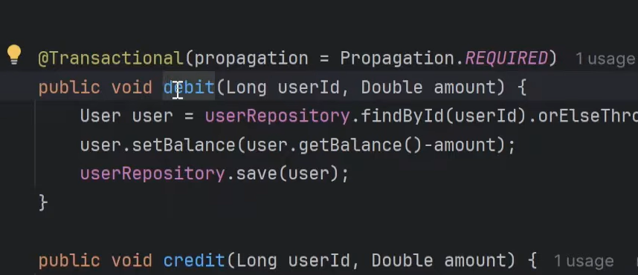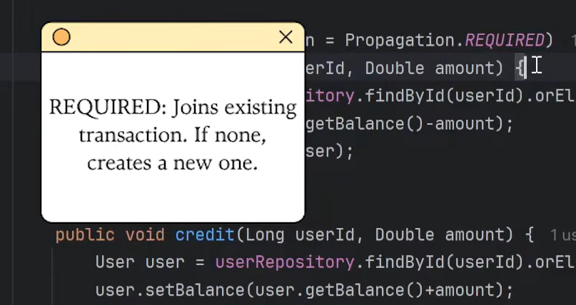

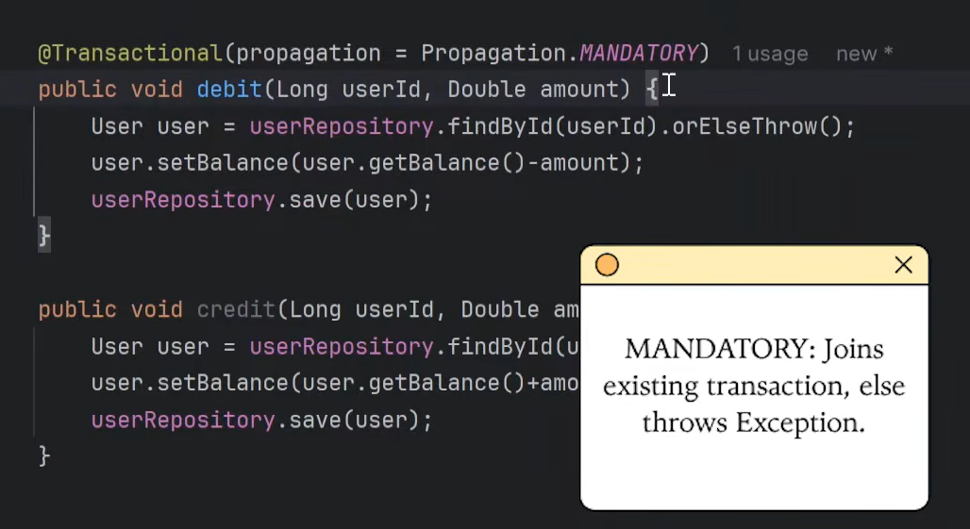
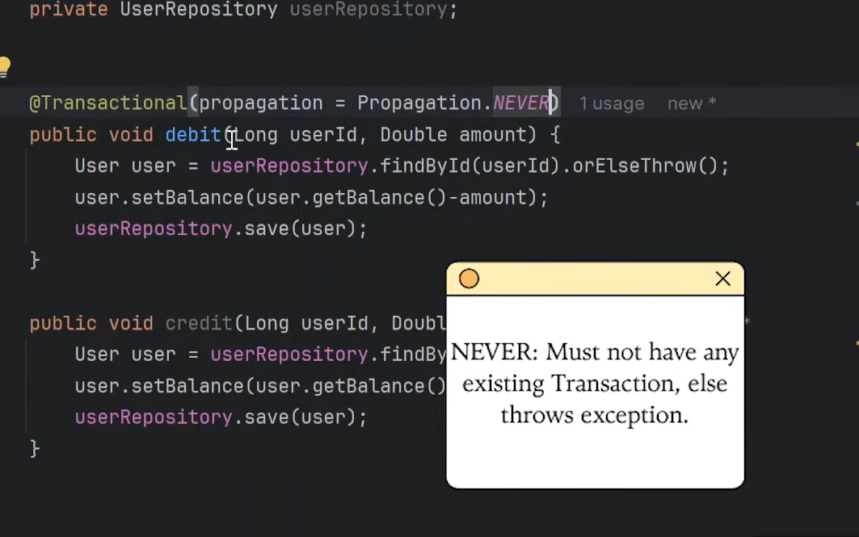
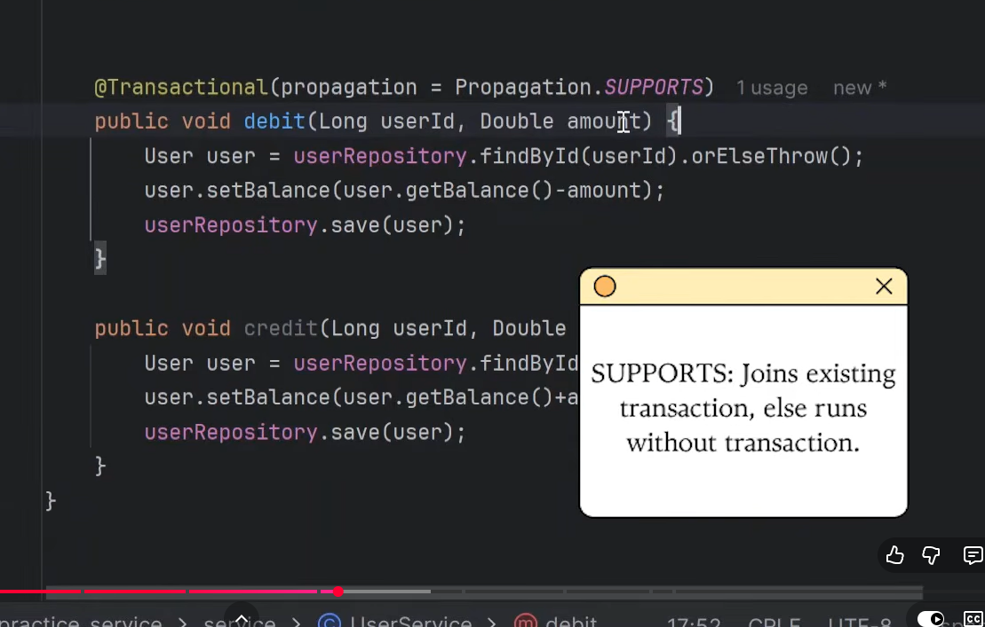
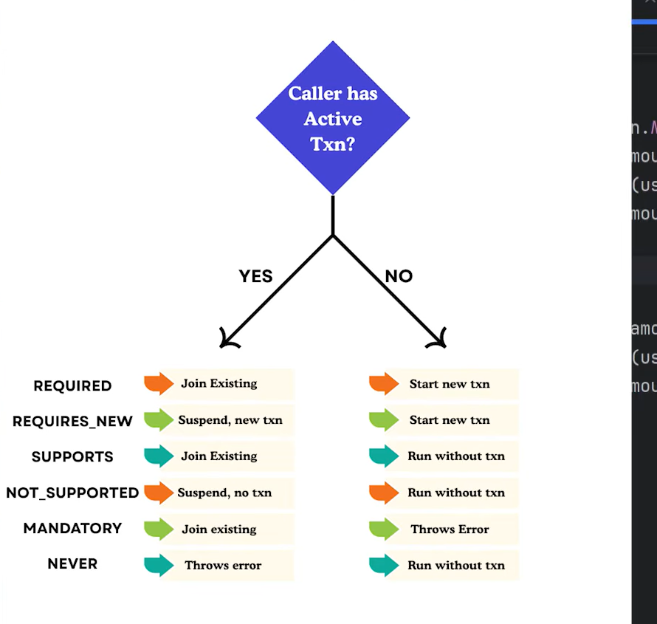
In database management and software engineering, readOnly is a configuration setting that tells the system (like Spring, Hibernate, or your database) that a transaction or connection will only read data (using operations like SELECT) and will not make any changes (like INSERT, UPDATE, or DELETE).
Building on our discussion of @Transactional, let's break down how it works and why it matters.

How readOnly Works in Spring Boot
When you annotate a method with @Transactional(readOnly = true), you are giving hints to both Spring and the underlying JPA/Hibernate provider:
- Disables Dirty Checking: Normally, Hibernate keeps a snapshot of entities to see if they change during a transaction (so it can automatically update the database). With readOnly = true, Hibernate skips this snapshot process, saving memory and CPU cycles.
- Optimizes Database Resources: Many databases and connection pools can optimize readOnly queries. For instance, they might route the query to a read-only database replica (scaling read traffic away from the primary database) or skip locking mechanisms since no data is being modified.
- Fails Fast on Writes: If you accidentally try to save, update, or delete data inside a readOnly = true method, Spring or the database will throw an exception, preventing unintended modifications.

Example Usage
Java
@Service
public class ProductService {

private final ProductRepository productRepository;

public ProductService(ProductRepository productRepository) {
this.productRepository = productRepository;
}

// Best practice for queries: optimized and safe
@Transactional(readOnly = true)
public List<Product> getAllProducts() {
return productRepository.findAll();
}

// Standard transaction because it modifies data
@Transactional
public Product updateProductPrice(Long id, BigDecimal newPrice) {
Product product = productRepository.findById(id).orElseThrow();
product.setPrice(newPrice);
return productRepository.save(product);
}
}

Key Takeaways
- readOnly = true: Use this for methods that only fetch or calculate data. It boosts performance and protects data integrity.
- readOnly = false (or default @Transactional): Use this for any method that performs inserts, updates, or deletes.
Would you like to know about other performance optimization attributes in Spring Boot transactions?

When to Use @Transactional in Spring Boot
No, not every database-related method needs @Transactional. Spring Data JPA repository methods (like save(), findById(), or delete()) are already transactional out of the box for single operations.
You only need to add @Transactional explicitly when you are orchestrating multiple database operations that must succeed or fail together, or when you need specific transaction configurations.

When You Must Use @Transactional
- Multi-Step Operations (Atomicity) If a method performs multiple writes (e.g., updating an account balance and creating a transaction log) and they all need to succeed or roll back together as a single unit of work.
Java
@Transactional
public void transferMoney(Long fromId, Long toId, BigDecimal amount) {
accountRepository.debit(fromId, amount);
accountRepository.credit(toId, amount); // If this fails, debit is rolled back
}
- Complex Read Operations with Lazy Loading If a method performs multiple queries or accesses lazy-loaded relationships outside a single repository call, placing @Transactional(readOnly = true) prevents LazyInitializationException by keeping the persistence context open.
- Custom Propagation and Isolation Rules When you need to control how transactions behave when nested inside other transactions (e.g., Propagation.REQUIRES_NEW) or define specific concurrency isolation levels.
- Custom Rollback Rules By default, Spring only rolls back transactions on unchecked exceptions (runtime exceptions and errors like NullPointerException or RuntimeException). If you need it to roll back on checked exceptions, you configure it explicitly:
Java
@Transactional(rollbackFor = Exception.class)

When You Do Not Need @Transactional
- Single CRUD Operations: Standard Spring Data JPA calls like repository.findById(id) or repository.save(entity) automatically manage their own transactions under the hood.
- Simple Read-Only Methods: If you are just fetching a single entity or running a basic query without lazy-loading concerns, @Transactional is often unnecessary overhead.

Part 1: Core & Conceptual Questions

Q1. How does @Transactional actually work under the hood?
- What they want to hear: You need to mention Spring AOP (Aspect-Oriented Programming) and Proxies (JDK dynamic proxies or CGLIB proxies).
- Key Answer Details: When you annotate a method with @Transactional, Spring creates a proxy around your bean. When an external client calls the method, the proxy intercepts the call, asks the PlatformTransactionManager to open a database connection, starts a transaction, invokes your actual method, and then either commits or rolls back depending on whether an exception was thrown.

Q2. Why does Spring not roll back by default on checked exceptions?
- What they want to hear: Spring follows the EJB convention.
- Key Answer Details: Unchecked exceptions (subclasses of RuntimeException and Error) represent unexpected system failures (e.g., NullPointerException, database down), so rolling back is the safest default. Checked exceptions (like IOException, custom business validation exceptions) often represent recoverable business logic failures where the developer might want to commit partial work (e.g., saving a failed attempt log). To force a rollback on checked exceptions, you must explicitly write: @Transactional(rollbackFor = Exception.class).

Part 2: The Classic Trap (Must-Know)

Q3. Why might @Transactional silently fail or do nothing even when added to a method? (Self-Invocation Problem)
- What they want to hear: This is the #1 interview trap for 3-year devs.
- Scenario:
Java
@Service
public class UserService {
public void registerUser() {
// Calling a transactional method from within the same class
this.saveToDatabase();
}

@Transactional
public void saveToDatabase() {
// db operations
}
}
- Why it fails: Spring's transaction management relies on the proxy. When registerUser() calls saveToDatabase() using this, it is executing directly on the target object, bypassing the proxy entirely. Therefore, no transaction is started.
- How to fix it: Inject the service into itself (circular dependency, though allowed in Spring via setter/field) or move saveToDatabase() into a separate service class.

Part 3: Scenario-Based Questions

Scenario 1: The Audit Log Dilemma (Propagation)
- The Problem: "You are building a payment processing service. If the payment fails, you want to roll back the order creation, but you must still save an audit log/error record to the database regardless of whether the payment succeeded or failed. How do you design this with @Transactional?"
- The Answer: You use transaction propagation.
  - The main method runs under the default Propagation.REQUIRED (joins or creates a transaction).
  - The audit logging method must be annotated with Propagation.REQUIRES_NEW.
Java
@Transactional
public void processPayment(PaymentRequest request) {
try {
orderRepo.save(new Order(request));
paymentGateway.charge(request); // Throws RuntimeException if payment fails
} catch (Exception e) {
auditService.logFailedAttempt(request); // Runs in a separate transaction
throw e; // Triggers rollback for the order
}
}

@Service
public class AuditService {
@Transactional(propagation = Propagation.REQUIRES_NEW)
public void logFailedAttempt(PaymentRequest request) {
auditRepo.save(new AuditLog(request)); // This commits independently and won't roll back with the outer transaction
}
}

Scenario 2: The Mysterious Performance Lag & Lazy Loading
- The Problem: "A REST API endpoint fetching a User and their list of Orders is throwing a LazyInitializationException or running too slow. You add @Transactional(readOnly = true) to the service method. What does readOnly = true actually change under the hood?"
- The Answer:
  - It prevents LazyInitializationException by keeping the Hibernate Session/Persistence Context open for the duration of the request.
  - Performance/Optimization: Depending on the underlying database and JPA provider, it can optimize the transaction by telling the database/Hibernate that no flush operations are needed, skipping dirty-checking mechanisms entirely, and sometimes routing read queries to a read-replica database.
How Spring Proxies Work
When the Spring IoC container initializes your beans, it scans for specific AOP annotations (like @Transactional, @Cacheable, or @Async). If an annotation is detected, Spring wraps the target object inside a proxy and injects this proxy into the application context instead of the raw bean. [1, 2, 3]
The execution flow follows a specific sequence: [1]
- Client Call: The client invokes a method, thinking it is calling the target bean directly. [1, 2]
- Interception ("Before" Logic): The proxy catches the call and executes predefined framework logic (e.g., opening a database transaction or checking a cache). [1]
- Delegation: The proxy passes the execution to the actual method on the target object. [1]
- Interception ("After" Logic): The proxy takes control again to execute post-method logic (e.g., committing the transaction or saving data to the cache). [1]
- Return: The final result is passed back to the client. [1]
The Two Types of Spring Proxies
Spring uses two distinct mechanisms to generate proxies at runtime, depending on the structure of your target class: [1, 2]
- JDK Dynamic Proxies: This is Spring's default mechanism if the target class implements at least one interface. Built directly into the Java platform (java.lang.reflect.Proxy), it generates a lightweight dynamic proxy that implements the exact same interfaces as your target class. [1, 2, 3]
- CGLIB Proxies: If the target class does not implement any interfaces, Spring switches to the open-source CGLIB library. CGLIB dynamically generates a subclass of the target class at runtime to override its methods. [1, 2]

